[GROUP 04]
TECH DOC
GAME PROJECTS 2025
[ART]
Ioanna Efthymiadou
Freya Lesschaeve
Roeland Van Sichem De Combe
[DEV]
Ádám Knapecz
Steven Van Den Hoven
[SOUND]
Igor Szuniewicz

Contents
Contents 1
1. INTRODUCTION 3
2. DEVELOPMENT STACK 4
2.1. Software & tools 4
2.2. Game engine 4
2.3. 2.3 3D software 5
3. TARGET PLATFORM 6
4. TARGET AUDIENCE & CONTEXT 7
5. PROGRAMMING GUIDELINES 9
5.1. Naming convention 9
5.2. Class organization 10
5.3. Portable C++ code 11
5.4. Use of standard libraries 11
5.5. Comments 11
5.6. Const correctness 12
5.7. Static assert 13
5.8. Override and final 13
5.9. Nullptr 13
5.10. Auto 13
5.11. Strongly-typed enums 13
5.12. Move semantics 14
5.13. Default member initializers 14
5.14. Code formatting 14
5.14.1. Braces 14
5.14.2. If-else 15
5.14.3. Tabs and indenting 15
5.14.4. Switch statements 15
5.14.5. Functions 16
5.15. Namespaces 16
5.16. Physical dependencies 16
5.17. Encapsulation 17
5.18. General style issues 17
5.19. API design guidelines 18
6. FOLDER STRUCTURE 20
6.1. Overview 20
6.2. ArtAssets 20
6.3. Dev 20
7. NAMING CONVENTIONS 23
7.1. Files 23
7.1.1. Substance Painter 26
7.2. Folders 27
8. UNITS 29
8.1. Autodesk Maya 29
8.2. Unreal Engine 31
8.2.1. Settings 31
8.2.2. Reference object 32
8.2.3. Character Movement component 33
8.3. Megascans 34
9. ART PIPELINE 35
9.1. Textures 35
9.1.1. PBR 35
9.1.2. Substance Painter 37
10. OTHER 38
10.1. Submit policy 38
10.2. Changelist description convention 38
10.3. Plugins 42
10.4. Tutorials 42

INTRODUCTION
INTRO
Welcome to Cozy Haven, where the days are slow, the tea is tepid, and something dreadful is creeping closer - something inescapable - or is it?
What if this bingo night was your last? What if this apple pie was your final taste of freedom?
But these grandmas won’t go down without a fight. With turbo-charged scooters and an arsenal of knitting needles, they’ll do anything to cheat death.
STORY
In this world, four grandmas who are dear friends are reminiscing in a retirement house. However, at the time they share their dearest memories. A mysterious figure appears to take them to their final voyage but receive a bet as well. When one reaches the shining gate, they’ll walk with a clean state. At this perilous state the friends turn to one another to get to the finish line.
FINALE
In the end, when one reaches the gate, they get to live on as they are but at the cost of losing their friends. As you see at the end credits (if we have time) the grandma looking back at the corpses with x crossing their eyes and having left this mortal realm.
TWIST
However, this can turn sideways as well, if all grandmas get eliminated. All will great death as a friend. And if two or more grandmas were to be reached the door at the same time, none shall pass for it is only one who gets granted life.
EXTRA
There will be no side questing, only a straight path to cross over obstacles, as you traverse these platforms and mix chaos along the road.

DEVELOPMENT STACK

Software & tools
Description | Software | Version
Game Engine | Unreal Engine | 5.5.3
Programming Language | C++ | C++20
Integrated Development Environment | Microsoft Visual Studio 2022 – Community Edition | 17.13.2
Integrated Development Environment | JetBrains Rider | 2024.3.6
Visual Studio Extension | JetBrains ReSharper C++ | 2024.3.6
Source Control Server | Perforce Helix Core (P4D) | 2024.2/2697822
Source Control GUI | Perforce Helix Core (P4V) | 2024.4/2711678
Modelling, UV, Rigging, Animation | Autodesk Maya | 2025.3
Modelling, PolyPaint | ZBrush | 2021.7
Texturing | Adobe Substance 3D Painter | 10.1.2
Texturing | GN PBR Validate | 1.0
RFX, 2D Assets | Adobe Photoshop 2025 | 26.4.1
Reference Image Organization | PureRef | 2.0.3
Sound Editing, Mixing, Mastering | REAPER | 7.34
Sound Editing, Mixing, Mastering | Steinberg Cubase | Pro 14
Sound Library | Soundly | 2025.01
Sound Library | Splice | 5.2
Brainstorming | Miro | Latest
Project Management | HacknPlan | Latest
Publishing & Development Logs | Itch.io | Latest
Documentation | Microsoft Office | Latest
Search Engine | Everything | 1.4.1.1026
Online Communication | Discord | Latest
The versions listed serve as the definitive reference throughout the entire project duration. For software - including game engines and modeling applications - any newly released stable version will be considered for an update, finalized only after thorough testing if deemed necessary. In exceptional cases, where a critical bug fix or a feature that could significantly enhance development is introduced, we may forgo extensive testing.

Game engine
ART
Since our game’s art style is a blend of hyper-realistic and stylized graphics, we decided to choose Unreal Engine as our game engine since it offers high fidelity realistic rendering and lighting with minimal effort as opposed to Unity - in which it would require much more tweaking around. Unreal’s default settings are exceptional when it comes to rendering realistic environments (e.g. real time raytracing system). Post processing effects are also way better since for example Depth of Field feels way more realistic in Unreal than in Unity. Furthermore, it offers a vast asset database that’s way more diverse when it comes to materials and assets. Unreal’s built in visual scripting is also great for quick prototyping without much coding, making even easier and accessible.
AUDIO
Unreal Engine offers a significant advantage over Unity in audio processing, thanks to its real-time DSP effects for sound groups - something Unity lacks due to its missing native submix system. With MetaSounds, Unreal provides a highly flexible and dynamic approach to audio, much like Blueprints but for sound, allowing complete real-time control. Additionally, built-in sidechain compression enables seamless audio balancing, such as dynamically lowering music or ambient sounds when key sound effects play, creating a more immersive and polished experience.
PROGRAMMING
Efficient time management is a crucial factor in development. A well-equipped engine can significantly accelerate the process by providing ready-made solutions, eliminating the need to reinvent the wheel. In this regard, Unreal Engine has been invaluable, particularly during prototyping. Its built-in, robust components - such as Character Movement, Movable, and SpringArm - offered immediate solutions to many of our challenges, often requiring nothing more than parameter adjustments without delving into complex programming.
While implementing logic in C++ introduces greater complexity, it ultimately pays off in terms of performance. As developers, we can seamlessly communicate with artists via Blueprints, allowing them to modify logic when needed. Blueprints also serve as a powerful tool for rapidly testing uncertain ideas without committing to extensive coding. Moreover, Unreal’s sophisticated Enhanced Input system, serialization system and well-structured architecture - Game Mode, Game State, and its intuitive inheritance model - further enhance development productivity.

2.3 3D software
For our 3D pipeline we will be using the Maya-Substance Painter workflow. Substance painter is an industry standard, texturing-focused, software and has a big and accessible material library. As a software it’s a good choice since it offers flexible, non destructive workflow with smart materials, masks and brushes. Further it allows for 3D painting directly on the model, which is a very intuitive and straightforward workflow.
Autodesk Maya as our modelling software is a choice made while keeping in mind features such as the built-in UV unwrapping tools that it offers, or the flexibility when it comes to exporting to game engines. We also have our own scripts that can automate parts of our workflow and speed up the production process.
We will be using ZBrush only for basic and more organic blocking out. Blocking out the character in ZBrush gives it instantly a more organic feel faster and with less effort than if we were doing it in Maya.

TARGET PLATFORM
Our game will be released on PC with a target resolution of 1440p and a desired minimum frame rate of 144 FPS. By default, we opt for the Epic quality setting; however, if we can sustain the minimum FPS, we may switch to the Cinematic setting. In the event of FPS fluctuations, we will consider transitioning to a lower scaling tier or reducing the resolution to 1080p, adjusting the minimum desired frame rate to 120 or 60 FPS accordingly.
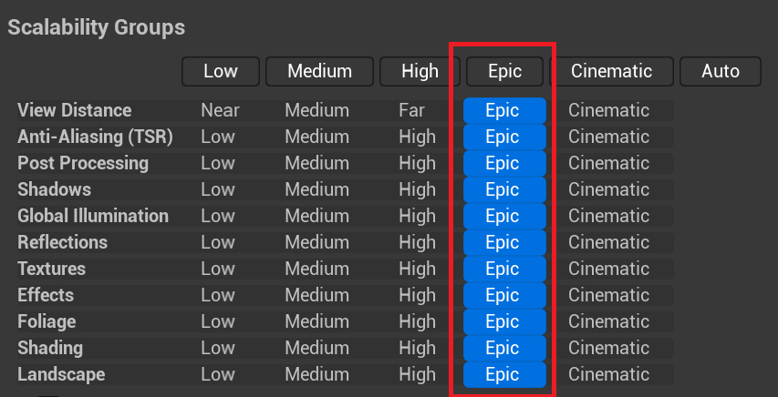
Since our game's quality objectives closely align with one of our key references, It Takes Two, we have adopted its recommended system requirements as our own.
OS | Windows 10 64-bit or Windows 11 64-bit
Processor | Intel Core i5 3570K or AMD Ryzen 3 1300x
Memory | 8 GB RAM
Graphics | Nvidia GeForce GTX 980 or AMD R9 290X
DirectX | Version 11
Network | -
Storage | 500 MB available space

TARGET AUDIENCE & CONTEXT
Our game is primarily designed for beginner to advanced competitive players who enjoy playing together in the same space (2-4 players) against one another, with matches lasting between 1 to 5 minutes. The user may have previously played similar competitive racing games (such as Super Mario Kart), making the game mechanics somewhat familiar - such as randomly generated pickups. However, even a player entirely new to the genre can quickly grasp the gameplay through a trial-and-error approach, becoming proficient within 30 seconds to a minute.
We have defined the following categories:
- Age: We recommend our game for players aged 12 to 40. If we were to assign an official Pan-European Game Information (PEGI) rating, we would classify it as PEGI 12 - partly due to the target age group and partly because the game may contain mild profanity (BAD LANGUAGE) as well as non-realistic violence against humanoid characters (VIOLENCE).
- Gender: Male or female.
- Device: PC with Windows-compatible controllers.
- Time commitment: Short sessions, 1 to 5 minutes.
- Number of players: 2-4 players
- Narrative: Since the story takes place in a retirement home, we assume that the player has or had a grandparent or older relative in their family or knows similar individuals within their social circle. As a result, themes surrounding aging and mortality are not unfamiliar, allowing the player to connect with the emotions tied to these experiences.
- Game Controls: Apart from basic character movement, the game requires the use of only 2-3 buttons, ensuring accessibility even for less experienced players.
- Game Mechanics: The mechanics are not overly complex and do not require extensive prior gaming experience, ensuring that new players can easily jump in without barriers to entry.
- Level Design: The realistic level design, featuring familiar objects, will evoke the environment of our grandparents, aiming to stir positive memories in the player. At the same time, the wall-of-death serves as a reminder of mortality, creating a stark contrast between the realms of the living and the departed.
- Character Design: The clay-like grandmothers are designed to evoke memories of childhood activities, fostering a sense of nostalgia.
- User Interface: A clean, paper-like UI design that evokes nostalgic, cartoon-style memories throughout the gameplay experience.
- Emotional Goals:
  - Fun & Easy: The game is designed to be lighthearted and entertaining, with colorful visuals, wacky pickups, and accessible controls.
  - Friendly Competition: Encourages a mix of skill and luck, making it exciting for both casual and experienced players.
  - Surprise & Unpredictability: Randomly generated items create unexpected moments, keeping players on edge.
  - Social Connection: Multiplayer mode fosters bonding, rivalry, and shared laughter among friends and family.
  - Nostalgia & Comfort: Many players will find themselves reminiscing about cherished moments with their grandparents or older relatives.
  - Sadness & Contemplation: The looming presence of the wall of death serves as a stark reminder of mortality.
  - Satisfaction & Mastery: After multiple playthroughs, players will experience a sense of skill progression and refinement of strategy.
  - Comeback Thrills: Rubberbanding mechanics allow players to make exciting last-minute comebacks, creating moments of triumph.
  - Mischief & Playfulness: Throwing pies, dropping obstacles, and sabotaging opponents add an element of cheeky fun.

PROGRAMMING GUIDELINES
Our coding standard will be primarily based on the Unreal Engine Coding Standard. Additionally, we have drawn supplementary ideas from Laura's (Mostly) Unreal Blog.
While the rules listed here can be found on the aforementioned sources, we consider it essential to document them explicitly. This ensures clarity for developers regarding the key principles we emphasize and are likely to encounter throughout the project's development.

Naming convention
All code and comments should use U.S. English spelling and grammar.
Use PascalCase. There is usually no underscore between words.
Good
LastMouseCoordinates
Bad
lastMouseCoordinates

Type | Format | Prefix | Suffix
Class | PascalCase
Struct | PascalCase
Enumerator | PascalCase
Method | PascalCase
Parameter | PascalCase
Member | PascalCase
Static member | PascalCase
Variable | PascalCase
Compile-time constant | PascalCase
Event | PascalCase | On | Event
Classes that inherit from UObject are prefixed by U.
class UActorComponent
Classes that inherit from AActor are prefixed by A.
class AActor
Classes that inherit from SWidget are prefixed by S.
class SCompoundWidget
Classes that are abstract interfaces are prefixed by I.
class IAnalyticsProvider
Enums are prefixed by E.
enum class EColorBits
{
ECB_Red,
ECB_Green,
ECB_Blue
};
Boolean variables must be prefixed by b.
bPendingDestruction
Type and variable names are nouns.
Method names are verbs that either describe the method's effect, or the return value of a method without an effect.
Macro names should be fully capitalized with words separated by underscores, and prefixed with UE_
#define UE_AUDIT_SPRITER_IMPORT
All variables should be declared on their own line so that you can provide comment on the meaning of each variable.
All functions that return a bool should ask a true/false question, such as IsVisible() or ShouldClearBuffer().
A procedure (a function with no return value) should use a strong verb followed by an Object. An exception is, if the Object of the method is the Object it is in. In this case, the Object is understood from context. Names to avoid include those beginning with "Handle" and "Process" because the verbs are ambiguous.
Prefix function parameter names with "Out" if:
- The function parameters are passed by reference.
- The function is expected to write to that value.
If an In or Out parameter is also a boolean, put "b" before the In/Out prefix, such as bOutResult.
Functions that return a value should describe the return value. The name should make clear what value the function returns. This is particularly important for boolean functions.

Class organization
The class implementation follows a structured order: public first, followed by protected, and finally private. After the mandatory GENERATED_BODY macro, each access modifier section begins with functions, followed by class members. Additionally, a blank line precedes each access modifier for clarity.
class MULTIPLEINPUTS_API AMyActor : public AActor
{
GENERATED_BODY()
public:
AMyActor();
protected:
void Foo();
private:
void Bar();
public:
float MyFloat;
protected:
int32 MyInt;
private:
FString MyString;
};

We organize class members according to the following rules:
- Grouped by visibility modifier, with UPROPERTY-annotated members having higher precedence.
- EditAnywhere properties always come first.
- EditAnywhere properties with a Category have higher precedence.
- The primary category must match the class name.
- Categories are separated by | without spaces.
- Categories follow PascalCase naming convention.
- Categories are listed in ascending alphabetical order.
- UPROPERTY members without EditAnywhere have lower precedence.
UCLASS()
class NOTTODAYDARLING_API Foo : public ACharacter
{
GENERATED_BODY()
private:
UPROPERTY(EditAnywhere, BlueprintReadWrite, Category = "Foo|Audio", meta = (AllowPrivateAccess = "true"))
TObjectPtr<UAudioComponent> EngineAudioComponent;
UPROPERTY(EditAnywhere, Category = "Foo|Input")
TObjectPtr<UInputMappingContext> InputMappingContext;
UPROPERTY(EditAnywhere, Category = "Foo|Mesh")
TObjectPtr<UStaticMeshComponent> FooMesh;
UPROPERTY(EditAnywhere)
TObjectPtr<USceneComponent> SceneComponent;
UPROPERTY()
FLinearColor CharacterColor;
float FooDeltaTime;
};

Portable C++ code
You’re supposed to use int32 for every int that may be serialized, e.g., on UPROPERTYs.

Use of standard libraries
When there is a choice between a standard library feature instead of Epic’s implementation, you should prefer the option that gives superior results. It's also important to remember that consistency is valued.
Avoid mixing UE idioms and standard library idioms in the same API.
Standard containers and strings should be avoided except in interop code.

Comments
For single-line comment, use a space after the //.
Good
// Called every frame
Bad
//Called every frame
Delete automatically generated comments and copyright notices. Remove empty single-line or multi-line comments.
We use Javadoc for documentation generation.
Good
/**
* Singleton-like access to this module's interface. This is just for convenience!
* Beware of calling this during the shutdown phase, though. Your module might have been unloaded already.
*
* @return Returns singleton instance, loading the module on demand if needed
*/
static inline IAITestSuite& Get()
Bad
/// <summary>
/// Singleton-like access to this module's interface. This is just for convenience!
/// Beware of calling this during the shutdown phase, though. Your module might have been unloaded already.
/// </summary>
/// <returns>Returns singleton instance, loading the module on demand if needed.</returns>
static inline IAITestSuite& Get()

Const correctness
Const is documentation as much as it is a compiler directive. All code should strive to be const-correct. This includes the following guidelines:
- Use west-const over east-const
- Pass function arguments by const pointer or reference if those arguments are not intended to be modified by the function.
- Flag methods as const if they do not modify the object.
- Use const iteration over containers if the loop isn't intended to modify the container.
void SomeMutatingOperation(FThing& OutResult, const TArray<Int32>& InArray)
{
// InArray will not be modified here, but OutResult probably will be
}
void FThing::SomeNonMutatingOperation() const
{
// This code will not modify the FThing it is invoked on
}
TArray<FString> StringArray;
for (const FString& : StringArray)
{
// The body of this loop will not modify StringArray
}
Const is also preferred for by-value function parameters and locals.
void AddSomeThings(const int32 Count);
void AddSomeThings(const int32 Count)
{
const int32 CountPlusOne = Count + 1;
// Neither Count nor CountPlusOne can be changed during the body of the function
}
Never use const on a return type. This inhibits move semantics for complex types, and will give compile warnings for built-in types. This rule only applies to the return type itself, not the target type of a pointer or reference being returned.
Good
// returning a reference to a const array
const TArray<FString>& GetSomeArray();
Bad
// returning a const array
const TArray<FString> GetSomeArray();
Good
// returning a pointer to a const array
const TArray<FString>* GetSomeArray();
Bad
// returning a const pointer to a const array
const TArray<FString>* const GetSomeArray();

Static assert
The static_assert keyword is valid for use where you need a compile-time assertion.

Override and final
The override and final keywords are valid for use, and their use is mandatory wherever possible.

Nullptr
You should use nullptr instead of the C-style NULL macro in all cases.

Auto
You shouldn't use auto in C++ code, except for the few exceptions listed below. Always be explicit about the type you're initializing.
C++20's structured binding feature should also not be used, as it is effectively a variadic auto.
Acceptable use of auto:
- When you need to bind a lambda to a variable, as lambda types are not expressible in code.
- For iterator variables, but only where the iterator's type is verbose and would impair readability.
- In template code, where the type of an expression cannot easily be discerned. This is an advanced case.
If you're sure you are using auto in an acceptable way, always remember to correctly use const, &, or * just like you would with the type name. With auto, this will coerce the inferred type to be what you want.

Strongly-typed enums
Enumerated (Enum) classes are a replacement for old-style namespaced enums, both for regular enums and UENUMs.
Good
// New enum
UENUM()
enum class EThing : uint8
{
Thing1,
Thing2
}
Bad
// Old enum
UENUM()
namespace EThing
{
enum Type
{
Thing1,
Thing2
};
}
Enums exposed to Blueprints must continue to be based on uint8.

Move semantics
All of the main container types - TArray, TMap, TSet, FString - have move constructors and move assignment operators. These are often used automatically when passing or returning these types by value. They can also be explicitly invoked by using MoveTemp, UE's equivalent of std::move.
Returning containers or strings by value can be beneficial for expressivity, without the usual cost of temporary copies.

Default member initializers
Prefer constructor body initialization over default member initializers.
Good
UTeaOptions::UTeaOptions()
{
MaximumNumberOfCupsPerDay = 10;
CupWidth = 11.5f;
TeaType = TEXT("Earl Grey");
DrinkingStyle = EDrinkingStyle::PinkyExtended;
}
Bad
UCLASS()
class UTeaOptions : public UObject
{
GENERATED_BODY()
public:
UPROPERTY()
int32 MaximumNumberOfCupsPerDay = 10;
UPROPERTY()
float CupWidth = 11.5f;
UPROPERTY()
FString TeaType = TEXT("Earl Grey");
UPROPERTY()
EDrinkingStyle DrinkingStyle = EDrinkingStyle::PinkyExtended;
};

Code formatting

Braces
Braces are always placed on a line by themselves.
Good
int32 GetSize() const
{
return Size;
}
Bad
int32 GetSize() const { return Size; }
Always include braces in single-statement blocks.
if (bThing)
{
return;
}

If-else
Each block of execution in an if-else statement should be in braces. This helps prevent editing mistakes. When braces are not used, someone could unwittingly add another line to an if block. The extra line wouldn't be controlled by the if expression, which would be bad. It's also bad when conditionally compiled items cause if/else statements to break. So always use braces.
if (bHaveUnrealLicense)
{
InsertYourGameHere();
}
else
{
CallMarkRein();
}
A multi-way if statement should be indented with each else if indented the same amount as the first if.
if (TannicAcid < 10)
{
UE_LOG(LogCategory, Log, TEXT("Low Acid"));
}
else if (TannicAcid < 100)
{
UE_LOG(LogCategory, Log, TEXT("Medium Acid"));
}
else
{
UE_LOG(LogCategory, Log, TEXT("High Acid"));
}

Tabs and indenting
Indent code by execution block.
Use tabs for whitespace at the beginning of a line, not spaces. Set your tab size to 4 characters. Note, spaces are sometimes necessary and allowed for keeping code aligned regardless of the number of spaces in a tab. For example, when you are aligning code that follows non-tab characters.

Switch statements
Except for empty cases (multiple cases having identical code), switch case statements should explicitly label that a case falls through to the next case. Either include a break, or include a "falls through" comment in each case. Other code control-transfer commands (return, continue, and so on) are fine as well.
switch (condition)
{
case 1:
...
// falls through
case 2:
...
break;
case 3:
...
return;
case 4:
case 5:
...
break;
default:
break;
}

Functions
Always leave one blank line between function declarations and their implementations. However, you may still group functions logically.
Good
void Foo();
void Bar();

void AGrandmaCharacter::Foo()
{
}
void AGrandmaCharacter::Bar()
{
}
Bad
void Foo();
void Bar();

void AGrandmaCharacter::Foo()
{
}
void AGrandmaCharacter::Bar()
{
}

Namespaces
We don’t use custom namespaces.

Physical dependencies
File names should not be prefixed where possible. For example, Scene.cpp instead of UScene.cpp.
All headers should protect against multiple includes with the #pragma once directive.
Forward declarations are preferred to including headers.
Good
class UWoofComponent;
UCLASS()
class ADog : public AActor
{
GENERATED_BODY()
UPROPERTY()
TObjectPtr<UWoofComponent> WoofComponent;
};
Bad
UCLASS()
class ADog : public AActor
{
GENERATED_BODY()
UPROPERTY()
TObjectPtr<class UWoofComponent> WoofComponent;
};
Try to include every header you need directly to make fine-grained inclusion easier: Include What You Use (shortened to "IWYU"). Only include headers where you absolutely have to: don't #include "CoreMinimal.h" everywhere.
Don't rely on a header that is included indirectly by another header you include.
Don't rely on anything being included through another header. Include everything you need.
Sort your #include statements alphabetically. It makes it way less likely that merge conflicts will happen, and way easier to fix them if they do.

Encapsulation
Enforce encapsulation with the protection keywords. Class members should almost always be declared private unless they are part of the public/protected interface to the class. Use your best judgment, but always be aware that a lack of accessors makes it hard to refactor later without breaking plugins and existing projects.
If particular fields are only intended to be usable by derived classes, make them private and provide protected accessors.
Use final if your class is not designed to be derived from.

General style issues
In function declarations or function call sites, do not add a space between the function's name and the parentheses that precede the argument list.
Good
void Foo(int32 Bar);
Bad
void Foo (int32 Bar);
Leave a blank line at the end of the file. All .cpp and .h files should include a blank line, to coordinate with gcc.
Always use the TEXT() macro around string literals. Without the TEXT() macro, code that constructs FStrings from literals will cause an undesirable string conversion process.
Pointers and references should only have one space to the right of the pointer or reference.
Good
FShaderType* Ptr
Bad
FShaderType *Ptr
FShaderType * Ptr
Shadowed variables are not allowed.
Avoid using anonymous literals in function calls.
Good
const FName ObjectName = TEXT("Soldier");
const float CooldownInSeconds = 5;
const bool bVulnerableDuringCooldown = true;
Trigger(ObjectName, CooldownInSeconds, bVulnerableDuringCooldown);
Bad
Trigger(TEXT("Soldier"), 5, true);.
Do not use brace initialization. Use copy initialization instead. Always space both sides of the = symbol.
Good
float MyFloat = 1.0f;
Bad
float MyFloat {1.0f};
float MyFloat = {1.0f};
Pre-increment indexes in for-loops.

API design guidelines
Boolean function parameters should be avoided.
Good
enum class ETeaFlags
{
None,
Milk = 0x01,
Sugar = 0x02,
Honey = 0x04,
Lemon = 0x08
};
ENUM_CLASS_FLAGS(ETeaFlags)
FCup* MakeCupOfTea(FTea* Tea, ETeaFlags Flags = ETeaFlags::None);
FCup* Cup = MakeCupOfTea(Tea, ETeaFlags::Milk | ETeaFlags::Honey);
Bad
FCup* MakeCupOfTea(FTea* Tea, bool bAddSugar = false, bool bAddMilk = false, bool bAddHoney = false, bool bAddLemon = false);
FCup* Cup = MakeCupOfTea(Tea, false, true, true);
Avoid overly-long function parameter lists.
Good
struct FTeaPartyParams
{
const FTeaFlags* TeaPreferences = nullptr;
uint32 NumCupsToMake = 0;
FKettle* Kettle = nullptr;
ETeaType TeaType = ETeaType::EnglishBreakfast;
float BrewingTimeInSeconds = 120.0f;
};
TUniquePtr<FCup[]> MakeTeaForParty(const FTeaPartyParams& Params);
Bad
TUniquePtr<FCup[]> MakeTeaForParty(const FTeaFlags* TeaPreferences, uint32 NumCupsToMake, FKettle* Kettle, ETeaType TeaType = ETeaType::EnglishBreakfast, float BrewingTimeInSeconds = 120.0f);
}
Avoid overloading functions by bool and FString.
void Func(const FString& String);
void Func(bool bBool);
Func(TEXT("String")); // Calls the bool overload!
Interface classes should always be abstract. Interface classes are prefixed with "I" and must not have member variables. Interfaces are allowed to contain methods that are not pure-virtual, and can contain methods that are non-virtual or static, as long as they are implemented inline.
Use the virtual and override keywords when declaring an overriding method. When declaring a virtual function in a derived class that overrides a virtual function in the parent class, you must use both the virtual and the override keywords.
class A
{
public:
virtual void F() {}
};
class B : public A
{
public:
virtual void F() override;
}
Use TObjectPtr<T> over T* for UObject pointer properties and container classes found in UCLASS and USTRUCT types.
Good
UPROPERTY()
TObjectPtr<ADog> Dog;
Bad
UPROPERTY()
ADog* Dog;
UObjects should be passed around by pointer, not reference.
Good
void AddActorToList(AActor* Obj);
Bad
void AddActorToList(AActor& Obj);

FOLDER STRUCTURE

Overview
The following diagram illustrates the main folder structure found in the Depot.
gamep_group04
├── ArtAssets
├── Design
├── Dev
├── Main
└── Prototype
- ArtAssets: This folder contains all source art assets that are used in the game.
- Design: In this folder we place all design assets + all design documents (art bible, sound bible, game design doc, tech doc, brainstorm doc, audio asset list).
- Dev: This is the folder where most of the development happens. It contains a single Unreal project. We start using this folder at the start of the production phase, not sooner!
- Main: This folder contains the stable version of the game.
- Prototype: This folder is only used during the prototype phase. In here we place various projects in which we test and experiment our game design ideas. Nothing of which we create in this folder is used in production, this is a playground where we can experiment and learn. Take your lessons and implement it for real during production. During production we can still use this folder to execute little tests and experiments, it's better we don't litter our Dev project with these.

ArtAssets
Lines marked with an asterisk (*) indicate a possible folder or file.
NotTodayDarling
├── Characters
│ ├── Common
│ │ └── Animation
│ └── *RockGranny
├── Effects
│ └── *Explosion
├── Environment
│ └── *Curtain
├── MaterialLibrary
│ ├── Debug
│ ├── *Metal
│ └── Utility
├── Placeables
│ ├── Obstacles
│ ├── Pickups
│ │ └── *Umbrella
│ └── Props
│ └── *BreadCrumbs
├── Platforms
│ └── *Spatula
└── UI
├── Buttons
├── Fonts
└── Images
└── Icons

Dev
Lines marked with an asterisk (*) indicate a possible folder or file.
Content
└── NotTodayDarling
├── Audio
│ ├── AttenuationPresets
│ ├── Blueprints
│ ├── Classes
│ ├── Effects
│ │ └── SubmixEffects
│ ├── Impulses
│ ├── MetaSounds
│ ├── Sounds
│ └── Submixes
├── Characters
│ ├── Common
│ │ ├── Audio
│ │ ├── Animation
│ │ │ └── *ABP_Granny
│ │ └── *M_Granny
│ └── *RockGranny
│ ├── *MI_RockGranny
│ ├── *SM_RockGranny
│ └── *T_RockGranny
├── Core
│ ├── Camera
│ │ └── *BP_Camera
│ ├── Characters
│ ├── GameModes
│ ├── Inputs
│ ├── Interactibles
│ ├── Pickups
│ ├── Platforms
│ ├── TriggerBoxes
│ └── UI
├── Effects
│ └── *Explosion
│ ├── NS_Explosion
│ └── T_Explosion
├── Environment
│ └── *Curtain
│ ├── *SM_Curtain
│ └── *T_Curtain
├── Maps
│ ├── Menu
│ └── Game
│ ├── *L_Main
│ └── *L_Lighting
├── MaterialLibrary
│ ├── Debug
│ ├── *Metal
│ │ ├── *M_Metal
│ │ └── *MI_Gold
│ └── Utility
├── Placeables
│ ├── Obstacles
│ ├── Pickups
│ │ └── *Umbrella
│ └── Props
│ └── *BreadCrumbs
├── Platforms
│ └── *Spatula
└── UI
├── Buttons
├── Fonts
└── Images
├── Icons
│ ├── *M_Umbrella
│ └── *T_Umbrella
└── *T_MenuScreen
During development, the Developers folder will be used for prototyping and testing ideas. Its contents will be stored locally and will not be synchronized with the Depot.
The Core folder will serve as the foundation for organizing C++ files.

NAMING CONVENTIONS
Our naming conventions will be based on the Gamemakin UE4 Style Guide and the Unreal Directive’s Asset Naming Conventions.
All structure, assets, and code in our project should look like a single person created it, no matter how many people contributed.

Files
The following rules have been extracted from the Gamemakin UE4 Style Guide, highlighting the most important ones. For any guidelines not covered in this section, the aforementioned Style Guide shall serve as the definitive reference.
- Forbidden characters: In any Identifier of any kind, never use the following unless absolutely forced to:
  - White space of any kind
  - Backward slashes \
  - Symbols i.e. #!@$%
  - Any Unicode character
- Allowed characters: Any Identifier should strive to only have the following characters when possible (the RegEx [A-Za-z0-9_]+)
  - ABCDEFGHIJKLMNOPQRSTUVWXYZ
  - Abcdefghijklmnopqrstuvwxyz
  - 1234567890
  - _ (sparingly)
We follow the basic “Prefix_BaseAssetName_Variant_Suffix” standard for naming our assets inside Unreal. Prefixes allow for quick identification of each asset while suffixes are used only when important information needs to be communicated.
- All assets should have a Base Asset Name. A Base Asset Name represents a logical grouping of related assets. Any asset that is part of this logical group should follow the standard of Prefix_BaseAssetName_Variant_Suffix.
- BaseAssetName should be determined by a short and easily recognizable name related to the context of this group of assets. For example, if you had a character named Bob, all of Bob's assets would have the BaseAssetName of Bob.
- For unique and specific variations of assets, Variant is either a short and easily recognizable name that represents logical grouping of assets that are a subset of an asset's base name. For example, if Bob had multiple skins these skins should still use Bob as the BaseAssetName but include a recognizable Variant. An 'Evil' skin would be referred to as Bob_Evil and a 'Retro' skin would be referred to as Bob_Retro.
- For unique but generic variations of assets, Variant is a two digit number starting at 01. For example, if you have an environment artist generating nondescript rocks, they would be named Rock_01, Rock_02, Rock_03, etc. Except for rare exceptions, you should never require a three digit variant number. If you have more than 100 assets, you should consider organizing them with different base names or using multiple variant names.
- Depending on how your asset variants are made, you can chain together variant names. For example, if you are creating flooring assets for our project you should use the base name Flooring with chained variants such as Flooring_Marble_01, Flooring_Maple_01, Flooring_Tile_Squares_01.
Below, we list the naming conventions for the asset types we are likely to use most frequently, categorized accordingly. Our naming system is based on the Unreal Directive Asset Naming Convention. In the case of a missing asset type, the aforementioned naming convention shall serve as the guideline.
Animation
Asset Type | Prefix | Suffix | Example | Notes
Animation Blueprint | ABP_ |  | ABP_Example
Blend Space | BS_ |  | BS_Example
Skeletal Mesh | SK_ |  | SK_Example
Skeleton | SKEL_ |  | SKEL_Example

Audio
Asset Type | Prefix | Suffix | Example | Notes
Attenuation |  | _ATT | Example_ATT
Media Sound Wave | MSW_ |  | MSW_Example
Reverb Effect | Reverb_ |  | Reverb_Example
Sound Attenuation | ATT_ |  | ATT_Example
Sound Class |  |  | Classes/Example | No prefix-suffix. Should be placed in a folder called Classes.
Sound Concurrency |  | _SC | Example_SC | Should be named after a SoundClass
Sound Cue | A_ | _Cue | A_Example_Cue
Sound Mix | Mix_ |  | Mix_Example
Sound Wave | A_ |  | A_Example

Blueprint
Asset Type | Prefix | Suffix | Example | Notes
Blueprint | BP_ |  | BP_Example
Enumerator | E |  |  | No underscore
Structure | S |  | SExample | No underscore

FX
Asset Type | Prefix | Suffix | Example | Notes
Niagara Emitter | NE_ |  | NE_Example
Niagara System | NS_ |  | NS_Example

Input
Asset Type | Prefix | Suffix | Example | Notes
Input Action | IA_ |  | IA_Example
Input Mapping Context | IMC_ |  | IMC_Example

Material
Asset Type | Prefix | Suffix | Example | Notes
Material | M_ |  | M_Example
Material (Post Process) | M_ | _PP | M_Example_PP
Material (User Interface) | M_ | _UI | M_Example_UI
Material Instance | MI_ |  | MI_Example

Miscellaneous
Asset Type | Prefix | Suffix | Example | Notes
Color Curve | Curve_ | _Color | Curve_Example_Color
Float Curve | Curve_ | _Float | Curve_Example_Float
Level | L_ |  | L_Example
Static Mesh | SM_ |  | SM_Example
Vector Curve | Curve_ | _Vector | Curve_Example_Vector

Texture
Asset Type | Prefix | Suffix | Example | Notes
Texture (Alpha/Opacity) | T_ | _A | T_Example_A
Texture (Ambient Occlusion) | T_ | _AO | T_Example_AO
Texture (Base Color) | T_ | _BC | T_Example_BC
Texture (Emissive) | T_ | _E | T_Example_E
Texture (Metallic) | T_ | _M | T_Example_M
Texture (Normal) | T_ | _N | T_Example_N
Texture (Roughness) | T_ | _R | T_Example_R
Texture (Specular) | T_ | _S | T_Example_S

User Interface
Asset Type | Prefix | Suffix | Example | Notes
Font | Font_ |  | Font_Example
Widget Blueprint | W_ |  | W_Example | Some use WBP_ as a prefix, but W is sufficient enough.

Substance Painter
From Substance we export with the Unreal Engine 4 (packed) template with a naming convention of T_$mesh_BC.
For example : T_Teapot_BC, T_Teapot_ORM, T_Teapot_N
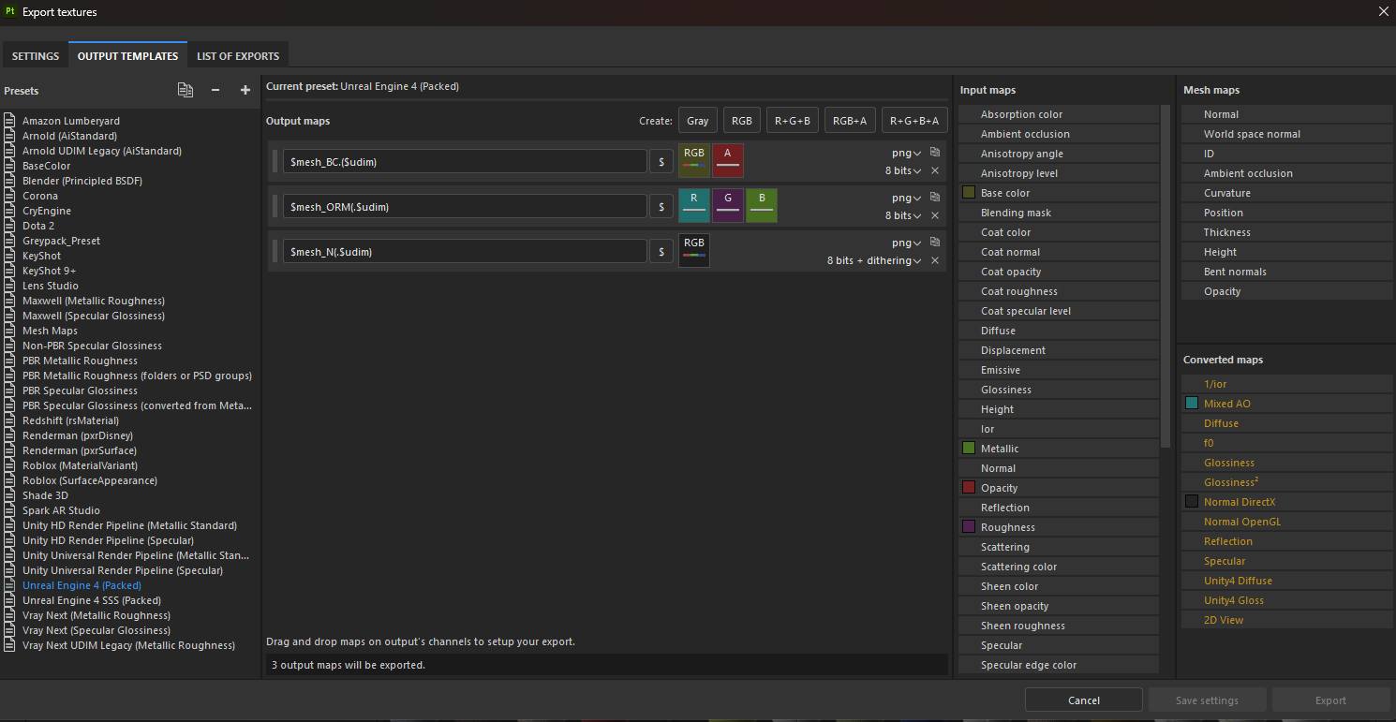
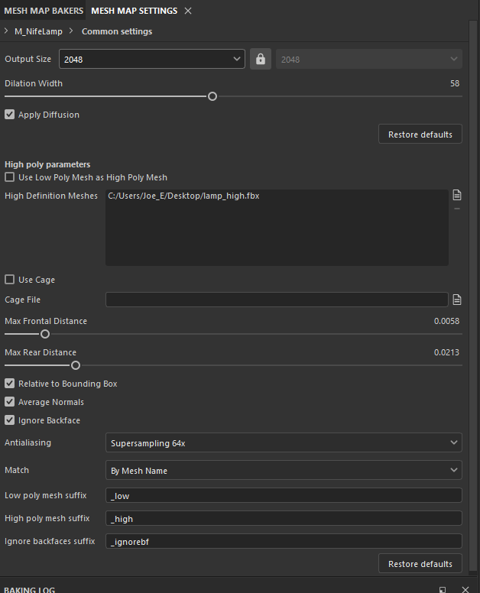
When baking inside substance painter we will be matching meshes by name. For this reason we will be naming mesh as following:
Mesh Name | Suffix High Poly | Suffix Low Poly
teapot | _high | _low
teapot | _top_high | _top_low
teapot | _top_high_1

Folders
The following rules have been extracted from the Gamemakin UE4 Style Guide and Anchorpoint’s blog, highlighting the most important ones. For any guidelines not covered in this section, the aforementioned Style Guide shall serve as the definitive reference.
- Always use PascalCase: PascalCase refers to starting a name with a capital letter and then instead of using spaces, every following word also starts with a capital letter. For example, DesertEagle, RocketPistol, and ASeriesOfWords.
- Never use spaces: Spaces can cause various engineering tools and batch processes to fail. Ideally, your project's root also contains no spaces and is located somewhere such as D:\Project instead of C:\Users\My Name\My Documents\Unreal Projects.
- Never use Unicode characters and other symbols: If one of your game characters is named Zoë, its folder name should be Zoe. Unicode characters can be worse than spaces for engineering tool and some parts of UE don't support Unicode characters in paths either.
Related to this, if your project has unexplained issues and your computer's user name has a Unicode character (i.e. your name is Zoë), any project located in your My Documents folder will suffer from this issue. Often simply moving your project to something like D:\Project will fix these mysterious issues.
Using other characters outside a-z, A-Z, and 0-9 such as @, -, _, ,, *, and # can also lead to unexpected and hard to track issues on other platforms, source control, and weaker engineering tools.
- No empty folders: There simply should not be any empty folders. They clutter the content browser.
- Never move folders, only move files.
- Do not rename folders: This will create a huge overhead of everything inside that folder. The better approach is:
  - Create a new folder.
  - Move all the files in there.
  - Fix redirectors.
  - Delete the old folder.
  - Commit to version control.

UNITS
We will be using a real-life scale for all meshes and characters, to ensure coherency and consistency throughout the project.
Software | Unit
Autodesk Maya | Meter
Unreal Engine | Centimeter

Autodesk Maya
Before exporting assets are scaled up x10 to make sure collision is working inside the engine.
To ensure that exported assets from Maya have the correct scaling in Unreal we switch to meters as working units inside Maya.
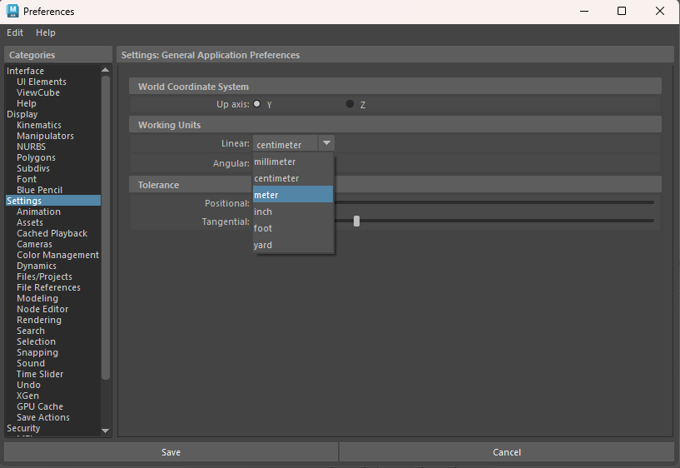
In the export settings we uncheck the automatic checkbox in Units section and instead choose to convert units to centimeters with a scale factor of 100. This ensures that the exported assets from Maya have the correct scale.
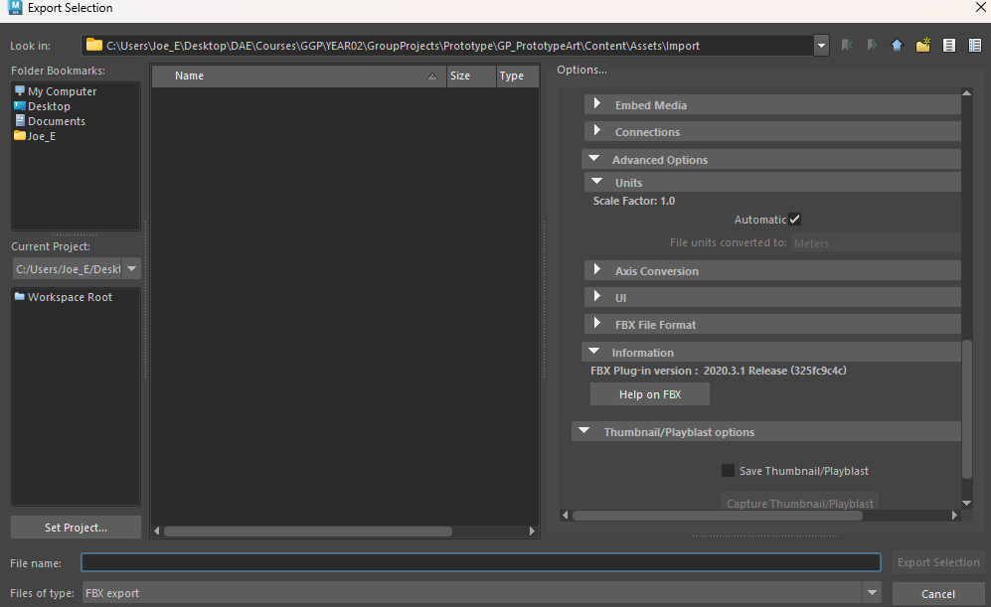
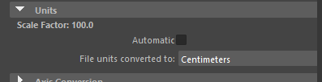
Every asset will have M_ImportMaterials applied for ease of use.

Unreal Engine
Scaling up inside Unreal Engine is never the way to go.

Settings
Ensure the values are correctly set in both Editor Preferences and Project Settings.
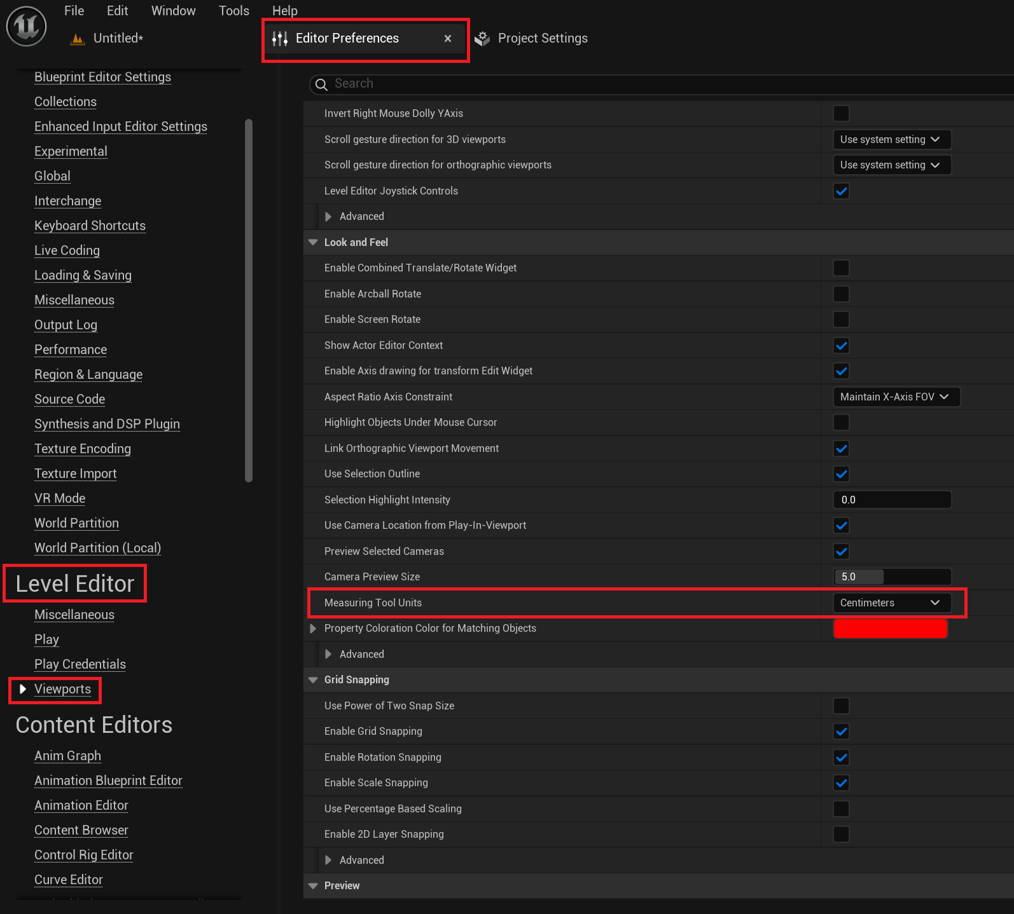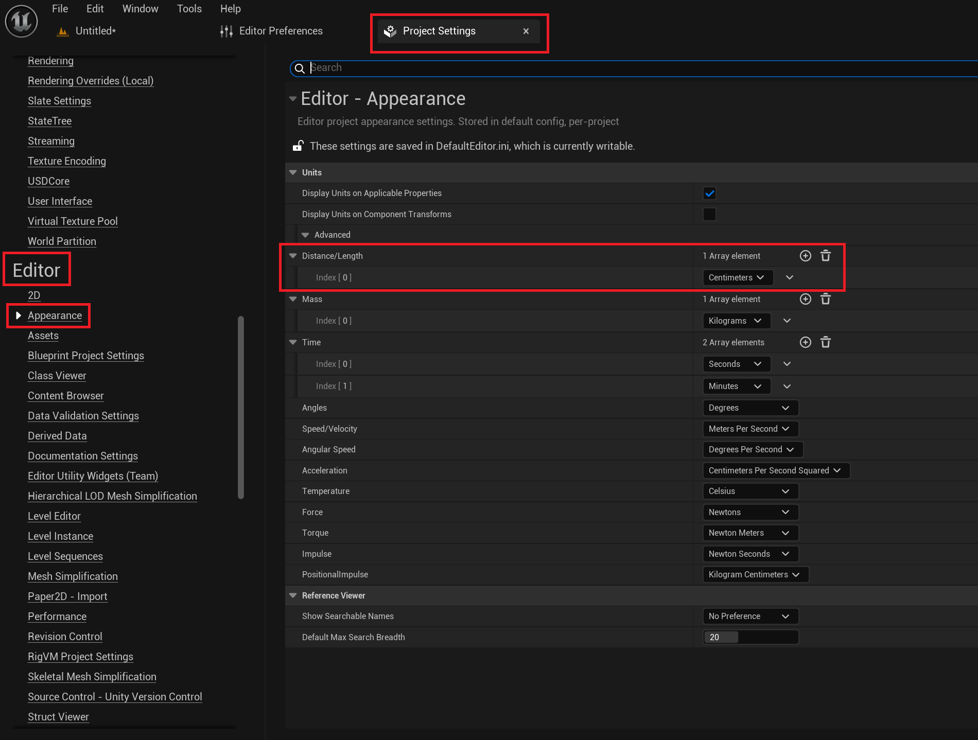

Reference object
For measurements, we will use the 100x100x100 cm cube available in /Engine/BasicShapes.
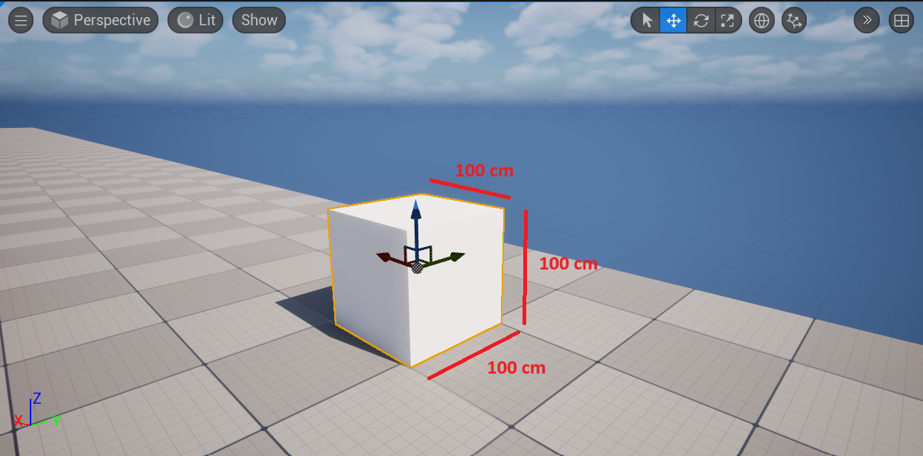
For additional assistance with precise measurements, we can use either the MI_ProcGrid Material Instance or the WorldGridMaterial Material.
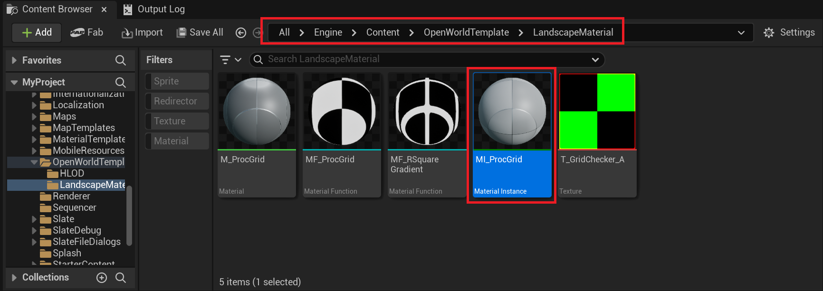
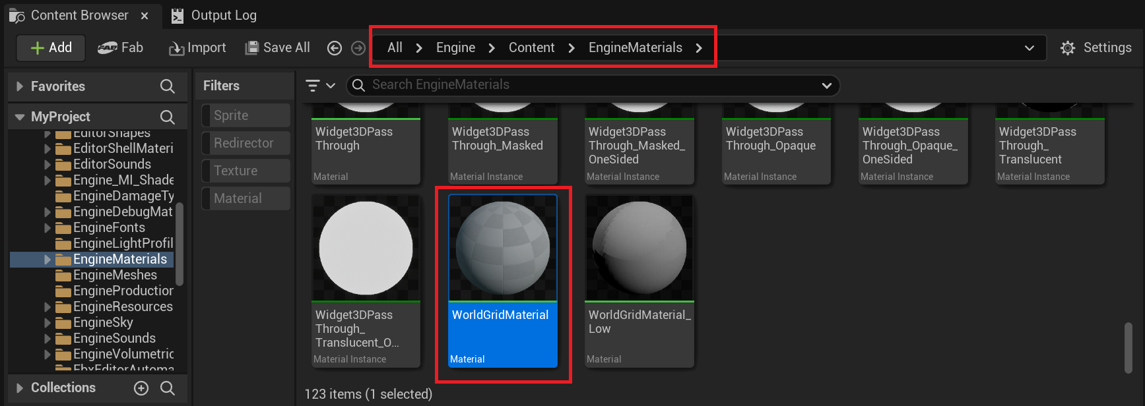
These materials divide the object into smaller 10x10 cm grid units.
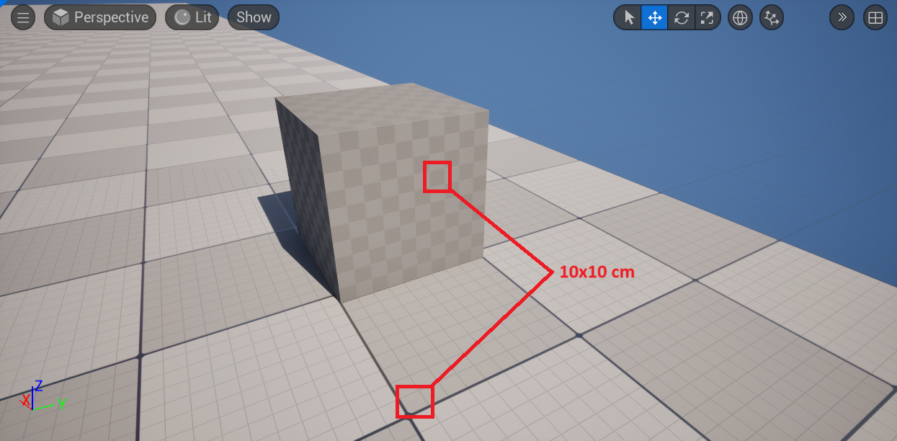

Character Movement component
The Character Movement component uses cm/s as its unit of measurement.
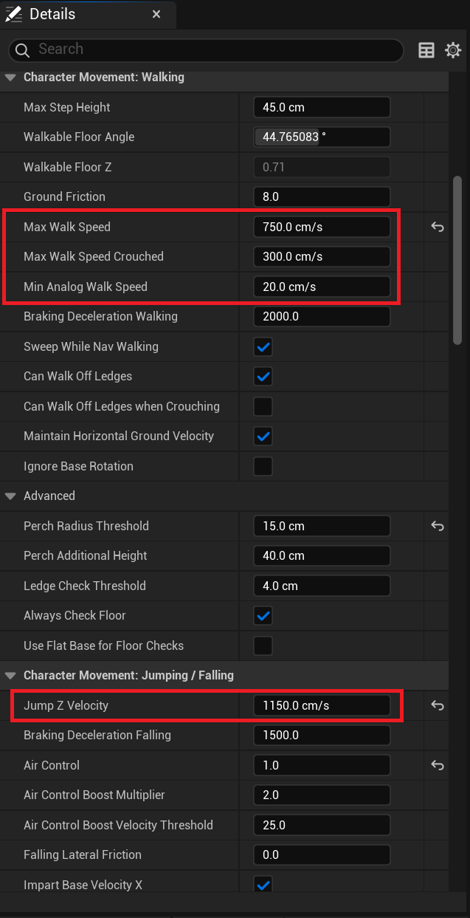

Megascans
Megascans assets imported from Unreal’s Fab marketplace don’t always have the correct scale (as shown below)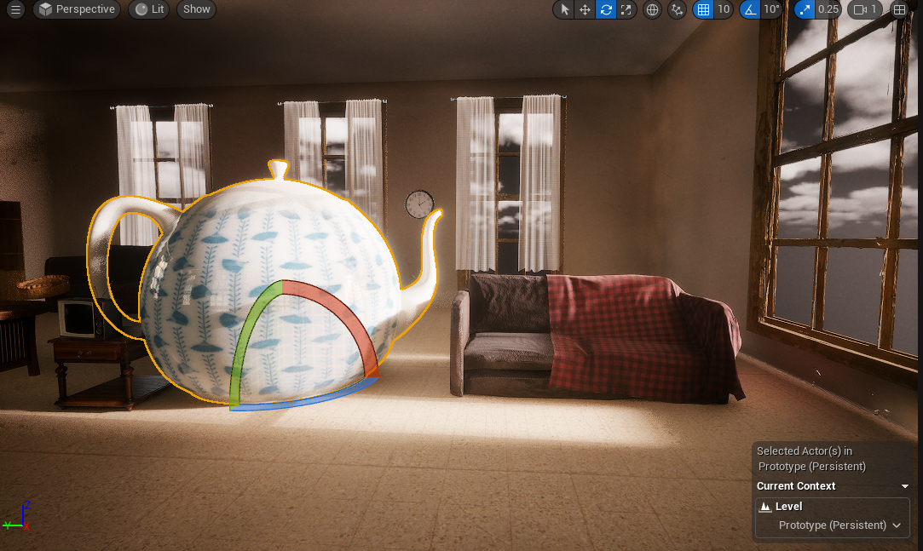
In case of incorrect scaling we will be comparing them to the 100x100x100cm reference cube and adjusting them as needed. Note! If an asset is not a static mesh and it’s interactable it’s always best to scale up than scaling down – so to avoid physics related issues. We also never scale non uniformly to avoid lighting issues.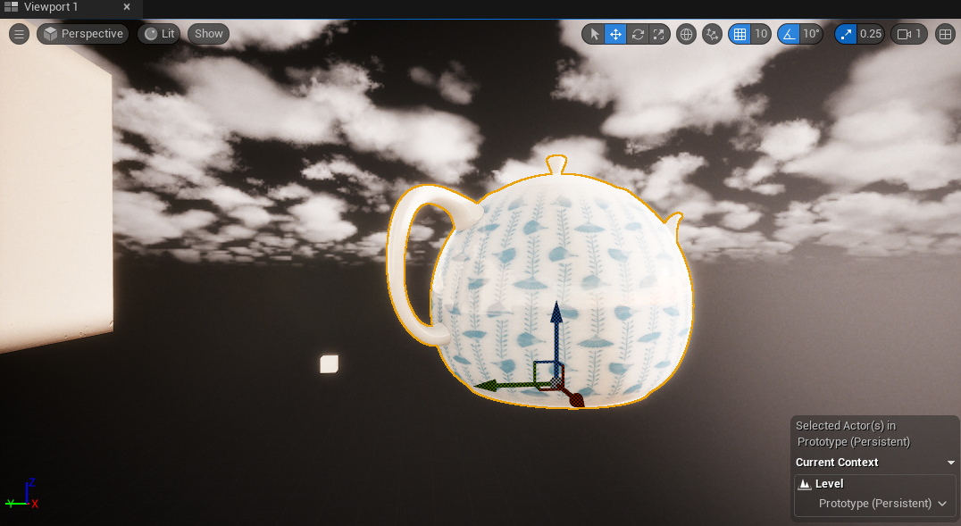

ART PIPELINE

Textures

PBR
We will be using the PBR pipeline to construct the assets with a material that respects the values of the real world. Since these characters will be made in clay and the assets in the world being realistic it's a must.
Provided down below are links to guide us in said workflow.
https://www.adobe.com/learn/substance-3d-designer/web/the-pbr-guide-part-1
https://www.adobe.com/learn/substance-3d-designer/web/the-pbr-guide-part-2
Along with the workflow chart there is a link to see the different values to get as physically accurate as possible.
https://physicallybased.info/
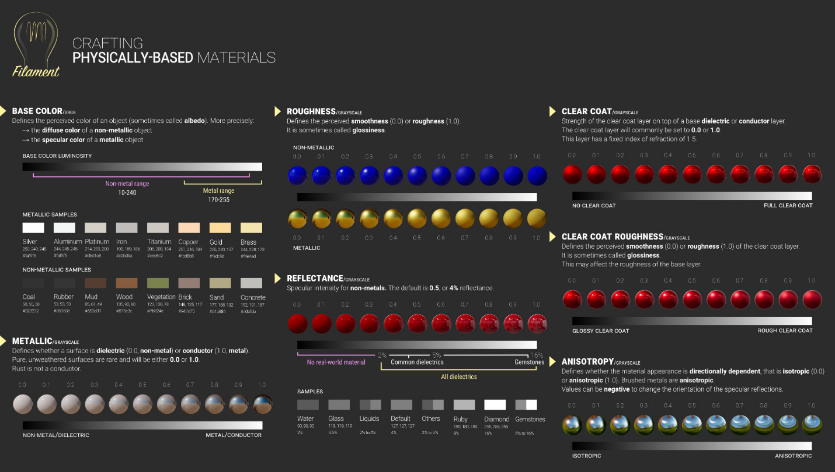
It's extremely important not to oversaturate the base color values! Everything we do to push values will be done in post, so if your model/character looks a bit muddy and not overly contrasty then you're doing good.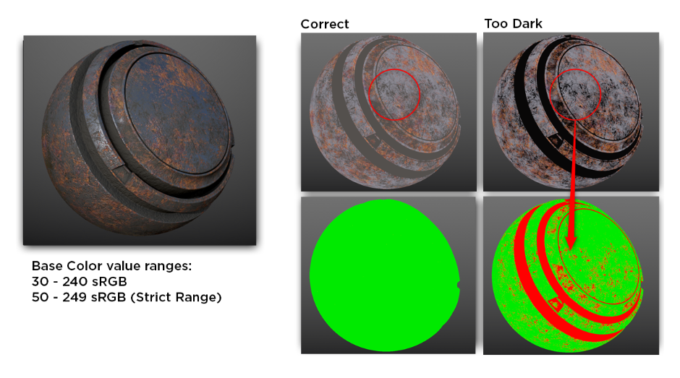
These values can be checked with the GN PBR validate tool. You can download this one on Artstation for non-commercial uses or pay a small price if it is used for commercial use.
https://www.artstation.com/marketplace/p/jdRD/substance-painter-gn-pbr-validate
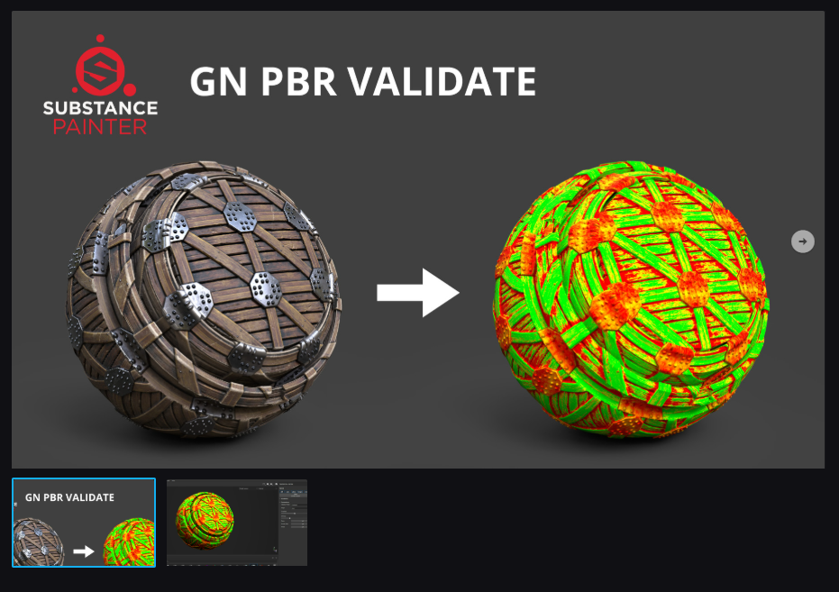

Substance Painter

Export settings
We are exporting all our textures at 2k (2048x2048) resolution . We later on downscale them inside Unreal since it will be easier having to downscale than to upscale.

OTHER

Submit policy
Always follow the procedure outlined below to avoid potential merge conflicts when uploading new or modified content.
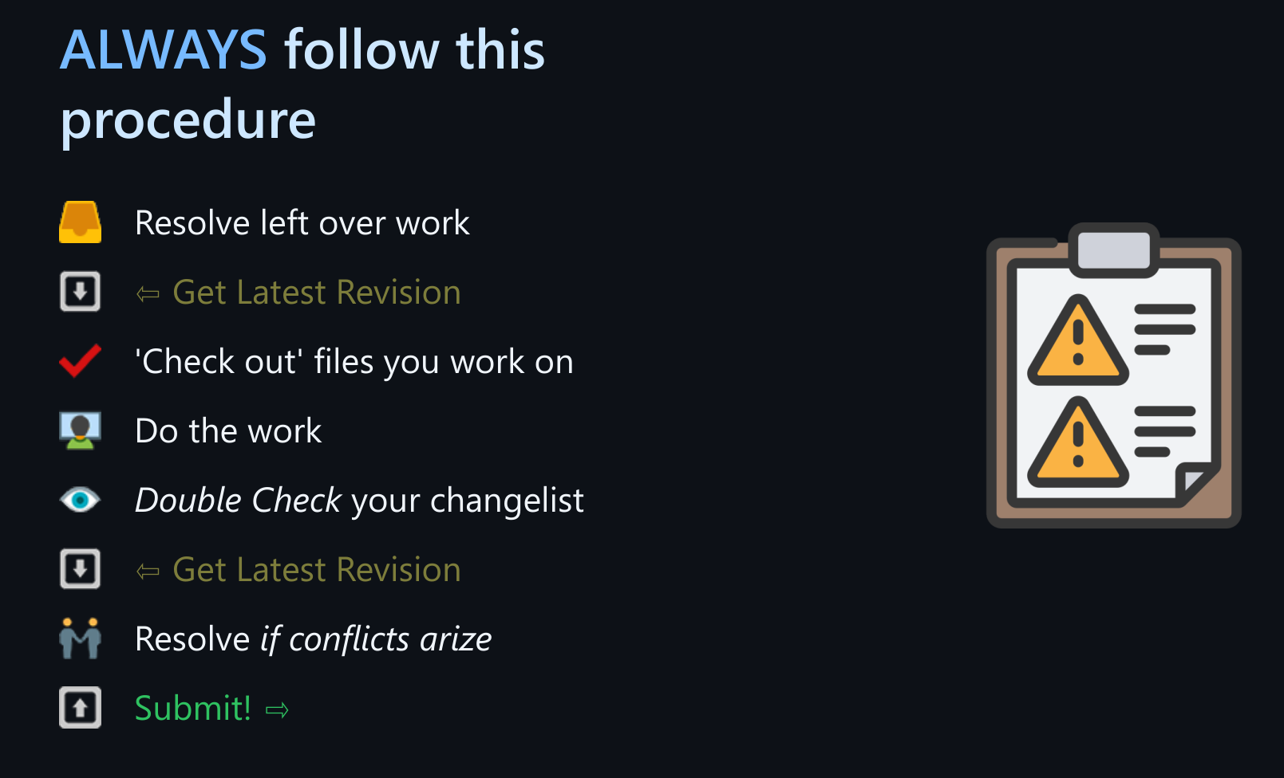

Changelist description convention
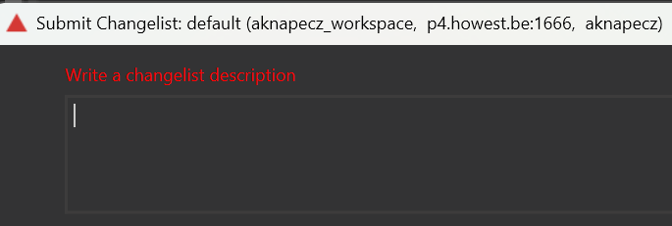
Whenever we upload content - be it new or modified - we must always provide a detailed description of what was changed, added, or updated in the project. These messages are essential not only for the uploader but also for the entire team, ensuring that, in the long run, we can look back at the project's history and gain a comprehensive understanding of its evolution and development.
Note: the description refers to the part following the type in the first line. The message encompasses the entire content, including the first line and the body starting from the second line.
To ensure clarity and consistency for everyone, we apply a changelist description convention, which consists of the following sections:
#id type: description (mandatory)
body (optional)
General rules:
- The first line of the message should be in lowercase.
- There should be a single space between #id and type.
- The type should be followed by a colon (:).
- There should be a single space between the colon (:) and the description.
- The body starts from the second line.
#id: The first part of the message should always be a HacknPlan ID.
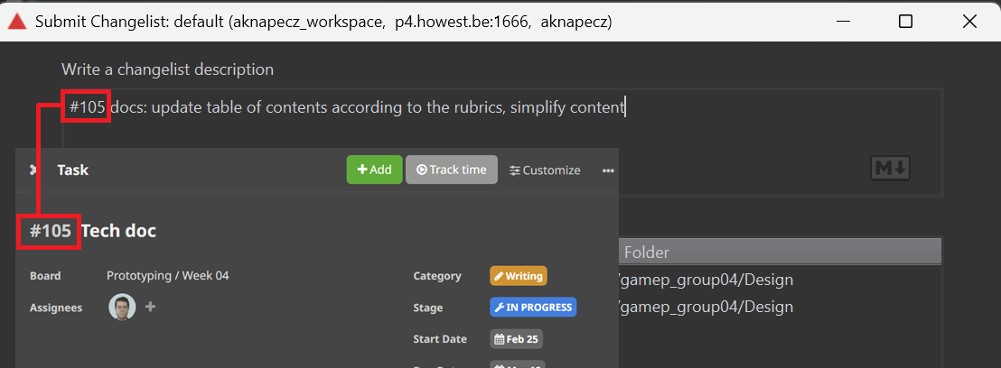
type: This convention is commonly used in Git commit messages, and we will adopt it as well. To ensure consistency, we will follow the guidelines outlined in the Eagerworks.com blog.
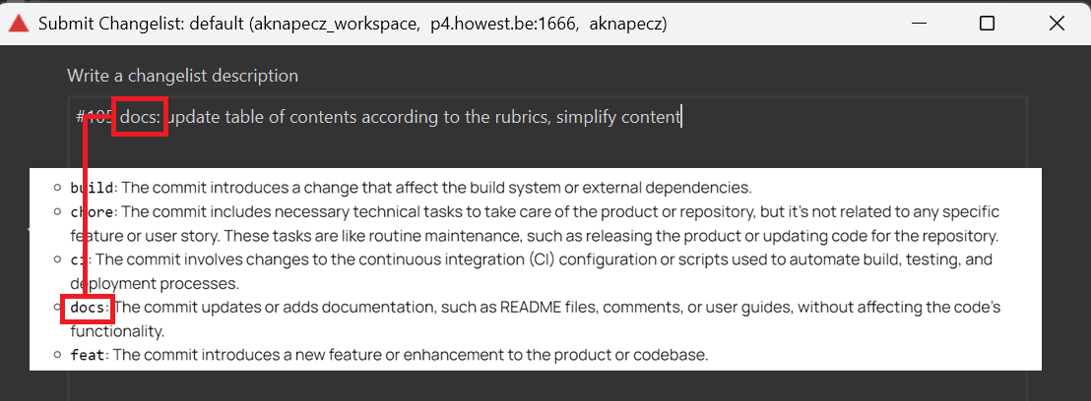
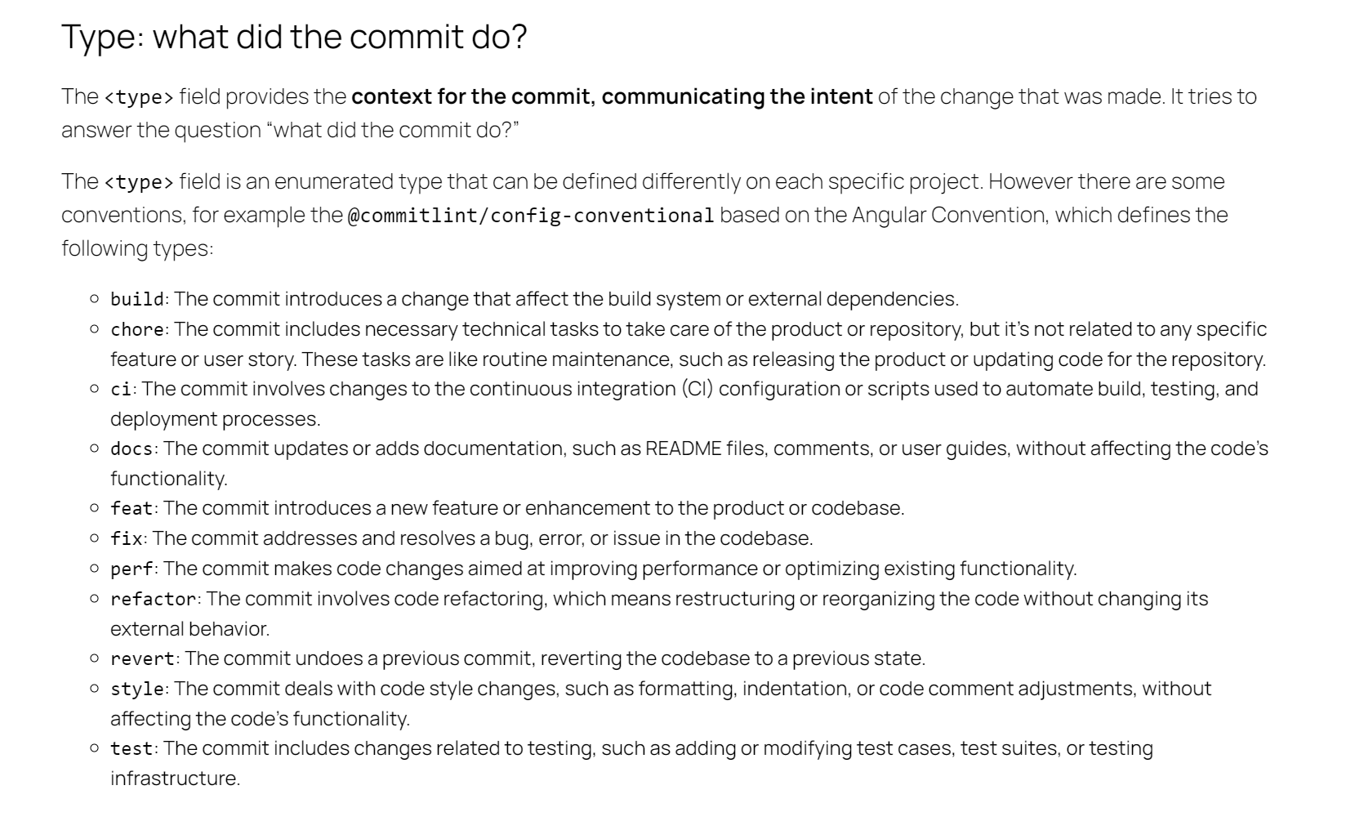
description: This should be clear and easily understandable for the reader. We will use the imperative mood, following the approach suggested by the cbea.ms blog.
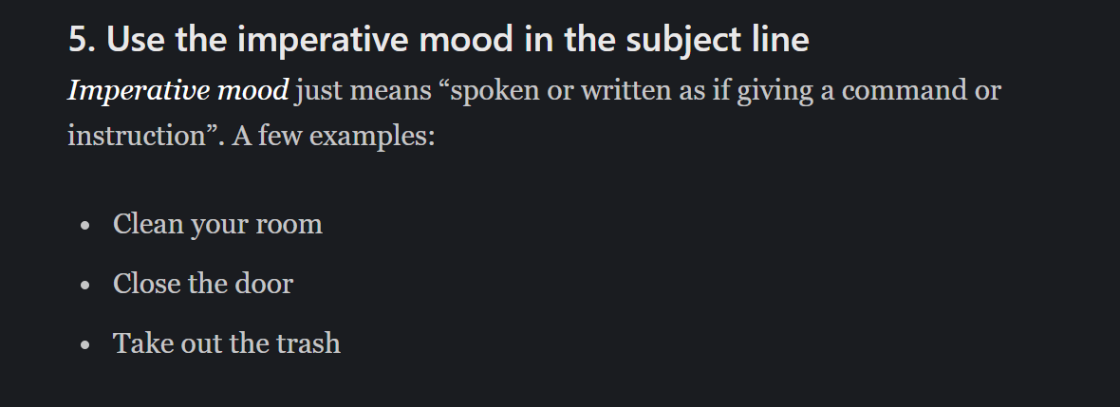
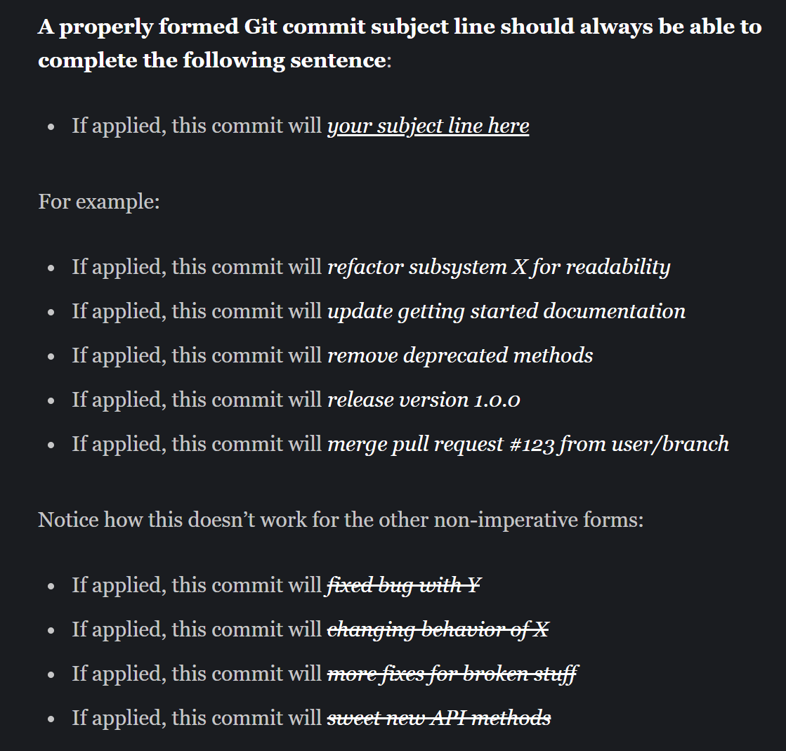
It is important to note that this rule may be omitted in the body section.
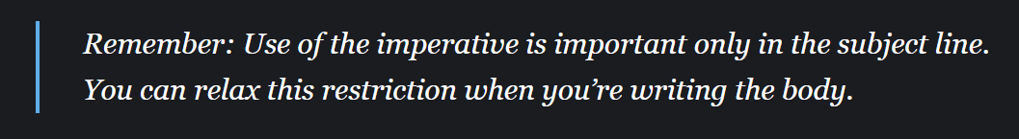
body: A more detailed and comprehensive version of the description. Here, we are free to articulate the message without adhering to the lowercase or imperative mood rules.
In rare cases, when a modification affects multiple tasks, it is acceptable for the message to include multiple descriptions. In such instances, the message should be structured as follows:
line 1: #id type: description 1 (mandatory)
line 2: body 1 (optional)
line 3: #id type: description 2 (mandatory)
line 4: body 2 (optional)
…
If possible, we should aim to avoid this. Under normal circumstances, a single submission should correspond to a single task.

Plugins
In addition to the default plugins, we use the following plugins:
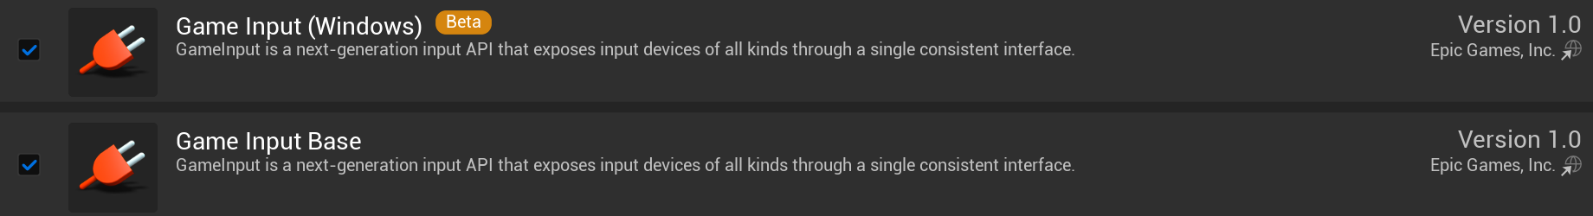
Certain custom plugins may cause compilation errors, preventing the project from launching. These must be disabled unless they are essential for the project.

Tutorials
Additional information related to software, such as installation guidelines, settings, useful insights, tips, and tricks, can be found in the Tutorials document located in the Design folder.
